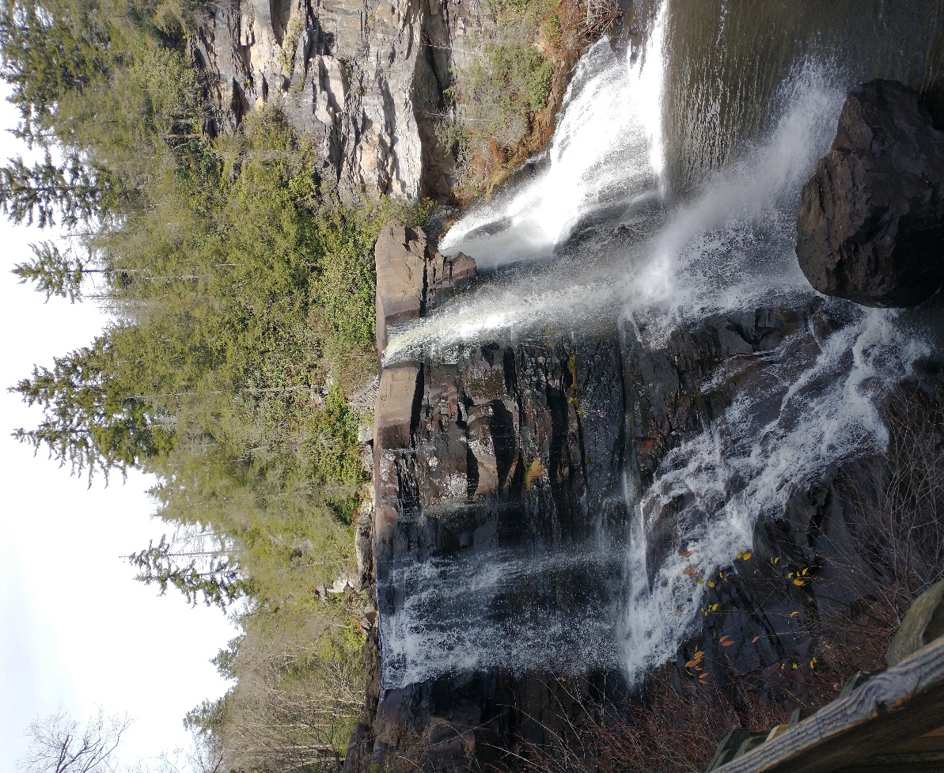
Wonderful

Words

Of Life

John 6:68
When: May 31st
Where: Eagle Valley Evangelical Free Church
17515 County Road 2 Christine, ND 58015
Guest Speaker: Daniel Borja
Schedule
1:00 Worship Service
2:30 Break
3:00 Special’s Service
5:30 Supper (Main meal provided. Please bring a salad or dessert.)
7:30 Fellowship at park (Weather permitting)

